Shabbos Stories For Parshas balak 5784

Volume 15, Issue 47 14 Tammuz 5784/July 20, 2024
Printed L’illuy nishmas Nechama bas R’ Noach, a”h
For a free subscription, please forward your request to keren18@juno.com
Past emails can be found on the website – ShabbosStories.com

Reb Shmuel
By Yoni Schwartz

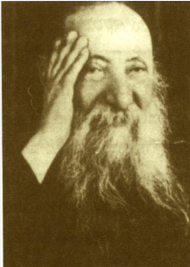

Rav Chaim Ozer Grodzinski, ZT”L, the Av Beis Din of Vilna, was known for his outstanding scholarship, and even greater kindness, loving each Jew no matter how religious or who they were. In the tumultuous times before World War II, most of the money sent to Europe to help the Jews was sent to him. As a result, he oversaw massive sums of money.
When distributing the funds, he was very careful to never discriminate between religious or non-religious Jews. Once, he was meeting with the head of the Joint Distribution Committee, Dr. Samuel Schmidt, who was not a Shabbos-observant Jew. At one point, the Rav stopped and asked him, “Is it okay if I call you Reb Shmuel?” (a title of great respect)
When Dr. Schmidt heard this, he began crying and said, “Rebbe, I do not keep Shabbos, Daven, or wear Tefillin, I do not deserve to be called ‘Reb’.” Dr. Schmidt wrote that when the Rav heard him say this, Rav Grodzinsky gently embraced his hand and said, “What do you mean? You came from America to a dangerous war zone to help Jews. Do you think you are not worthy of respect? Do you think you are not worthy of being called ‘Reb’?”
Dr. Schmidt said that on that day, when he came home, he put on Tefillin and became Orthodox. The respect Rav Chaim Ozer had for each Jew - and his appreciation for the good in them - is inspiring.

Reprinted from the Parshas Korach 5784 email of Torah Sweets.

Treasures of Emunah
The Power of Being Happy
Rabbi Elimelech Biderman

A poor person earned his parnassah by digging and selling clay. Once, he was digging in the earth, and found a precious stone, worth a great fortune. He went to a jeweler to have it appraised. The jeweler said, "There is no one in this country that can pay for its value. You should travel to London, to the capital city..."
But he was poor, and he didn’t have money to travel. He sold everything he owned, and he went from house to house collecting handouts, until he had enough money to travel to the port.
He wanted to get on a boat that was heading to London, but he didn’t have money, so he went to the captain and showed him his diamond. The captain immediately welcomed him onto the ship with great honor. "You are
surely wealthy." He gave him a first-class private cabin with all amenities, as is given to the very wealthy.

Enjoyed Looking at His Diamond
His cabin had a porthole to the sea and he would always make himself happy with his diamond. He would especially cherish and look at his diamond as he ate his meals, because joy is good for digestion.
Once, he was eating his meal with the diamond on the table and he fell asleep.
The cabin boy came in, took the tablecloth with the crumbs on it and dumped them into the sea. He didn’t realize that the diamond was on the table. When this man awoke, he understood what happened, and was immensely distressed. He almost became insane from agony.
But he couldn’t afford being sad, because the captain was a crook, and would surely kill him if he didn’t pay for the passage. So, he continued to be happy, pretending as though nothing happened.
The captain used to come and chat with him for some time every day, and that day, he came as usual. The man pretended that he was happy. It wasn't noticeable on his behavior that anything changed.
The captain said to him, "I know that you are wise and honest. I want to buy
a lot of wheat to sell in London. I can earn a lot of money from this transaction, but I'm afraid people will say that I'm stealing money from the king's treasury. Therefore, I want the purchase to be on your name. I will pay you well for this." The man liked the idea, and agreed.
As soon as they arrived in London and purchased the wheat, the captain died.
The wheat remained with this person and he profited several times more than the value of the lost diamond.
Reb Nachman of Breslov concluded from this mashal, "The diamond was never his. The proof of that is that it got lost. The wheat was his, and the proof is that its profits remained by him. And the reason he got what’s rightfully his is only because he remained happy.”

Reprinted from the July 4, 2024 email of Torah Times Media

The Importance of the Chazon Ish’s Mincha Prayer

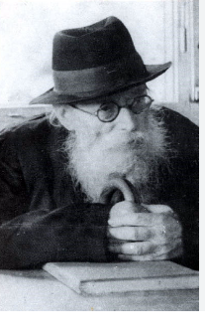
Reb Nechemia Beker had a serious question that needed the insight from a Gadol b’Torah. His wife had suffered complications after childbirth that the doctors said would require her to undergo high-risk surgery. They weren’t convinced that the surgery would even save her, but it was the only solution that they could offer. In addition, the surgery would prevent her from being able to bear any more children.
He thus approached the Chazon Ish, zt”l, to ask how he should proceed. The Chazon Ish replied, “If that is the case, then what’s the question? Certainly, she should have the surgery. It is pikuach nefesh. You must proceed with the surgery!”
With his answer, R’ Nechemia got up and began to leave the house of the Chazon Ish, determined on surgery. Before he could, the Chazon Ish asked him if he’d davened Minchah, which R’ Nechemia replied that he hadn’t. The Chazon Ish suggested that he stay and daven Minchah with them, and so he did.
After Minchah, the Chazon Ish called R’ Nechemia over, told him that after rethinking the matter, he decided that his wife didn’t need the operation. She’ll be fine by avoiding the surgery.

“Why Did the Rav Change His Mind?”
Shocked by the response, Reb Nechemia asked, “Just several moments ago, the Rav clearly affirmed that surgery was a necessity, since it was a matter of life and death, r”l. Why now did the Rav change his mind?”
The Chazon Ish simply replied, “That reply was before I davened Minchah. But now it is after Minchah. Now is a new situation. After davening, things change.” It didn’t take long for Rebbetzin Beker to have a complete turnaround. She lived to bear another eight children and lived past the age of eighty.
One davening can be the single event to merit the yeshuah. One davening sufficed for her complete salvation. Going from a lifethreatening situation to a complete salvation changed with one Shemoneh Esrei. Hashem is there for us, and anyone’s davening has the potential to bring the special yeshuos

Reprinted from the Parshas Korach 5784 email of Zichru Toras Moshe.

The Broken Shidduch
By Rabbi David Ashear

R’ Yisrael Meir Felman recounted that Aryeh Fink,* a boy from the Slabodka Yeshivah, got engaged, but before the wedding, someone slandered him to the parents of the kallah and they called off the shidduch.
Devastated, Aryeh turned to R’ Felman for guidance. R’ Felman went to R’ Shach and told him what had happened, adding, “I personally know that everything they said about Aryeh is false. What should I do?” R’ Shach offered to personally accompany R’ Felman on the three-hour drive to the girl’s parents’ home to talk to them.
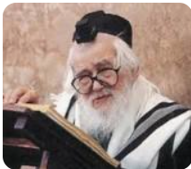
Rabbi Elazar Shach

When they arrived, R’ Shach began to sing Aryeh’s praises. “I heard your daughter was engaged to Aryeh Fink and I want to personally tell you how fortunate you would be to get such a wonderful young man as a son-in-law!” He then proceeded to describe all his great qualities.
After R’ Shach and R’ Felman left, the parents immediately called the shadchan to ask to reinstate the shidduch. In that instance, R’ Shach did not just say, “If it’s meant to be, it will happen.”
Since the parents were fed negative information about Aryeh, it was not logical to expect them to reverse their decision to end the shidduch. They needed to be spoken to first; therefore, R’ Shach made an effort to help. Had the parents remained opposed to the shidduch, then R’ Shach could have said, “It’s not meant to be. We tried.” (Living Emunah on Shidduchim)

Reprinted from the Parshas Korach 5784 email of The Weekly Vort.

Saved From Cremation
By Mendel Ehrenreich

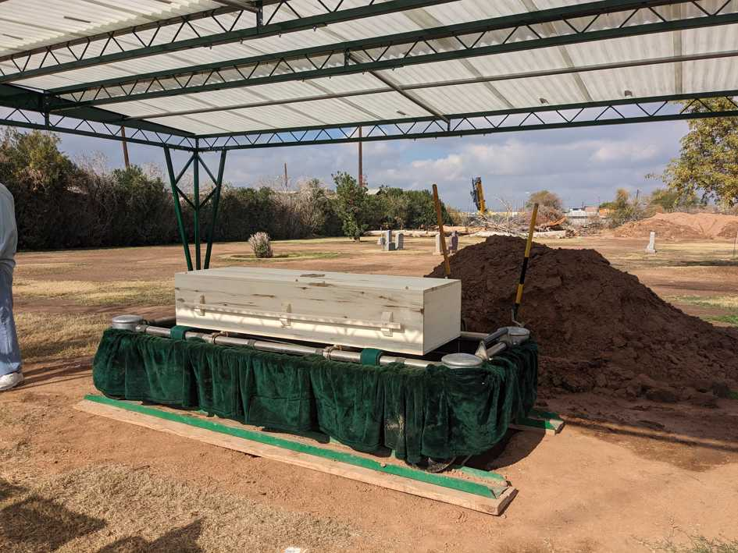
After reaching out to a local Chabad rabbi in his last days, Robert Goldberg chose a Jewish burial instead of cremation.

Jewish law commands each Jew to return the gift from Above—our physical bodies—to the earth and that the deceased is treated with reverence. So, when a Chabad rabbi in a small town in Arizona had the opportunity to help a fellow Jew, who’d recently died, he rushed to help.
Lake Havasu City is in the center of Arizona’s vast northwest desert. It has long been seen as too remote, not a fertile ground for anything Jewish. That was until Rabbi Mendel Super, his wife, Itta, and their children moved there in 2022, to establish Chabad of Lake Havasu City.
Since their move, the Supers have provided religious services and Jewish opportunities to the residents of the city and also worked closely with local business and organizations to build up Jewish infrastructure. A key part of their ethos is to provide for any Jew at any lifecycle point in their lives.
It was no surprise then that last year, during the festival of Chanukah, the Supers received a phone call from a local hospice provider telling them that a Jewish patient had requested to see a rabbi.
Wasting no time, the rabbi headed over to the address provided and met Robert Goldberg, 67, and his mother, Margo, a 91-year-old Holocaust survivor. Robert had received the diagnosis for terminal Stage Four oral cancer several months earlier and he and his mother, who lived in Newport Beach, Calif., had come to Arizona to spend his last days in the company of friends.
Robert seldomly attended anything Jewish; he never had a bar mitzvah or even received a Jewish name, but when he knew his days were numbered, there was something within him telling him to turn to G-d.
Upon meeting the Goldbergs, the rabbi helped Robert wrap tefillin for the first time in his life. Thus, he officiated the “bar mitzvah,” offered the mother and son duo some traditional Chanukah doughnuts, and lit the menorah with them.
It was a moment of connection that Robert never had; he was being cared for and cared about. Super then helped the sick man say the end-of-life prayers (Viduy) and Shema.

‘Would You Be Willing to Change Your Plans?’
In conversation with Robert, the rabbi discovered that due to his financial situation, he had chosen to take the path of a prepaid cremation in the place of a kosher and traditional Jewish burial.
“I approached Robert with an offer," Super told Chabad.org. “I asked him, ‘Robert, if I can arrange to collect and raise the funds for a Jewish burial for you, would you be willing to change your plans?’ To which he immediately and resoundingly answered, ‘Yes!’”
The young rabbi sprung into action and contacted the Sinai Mortuary of Arizona in Phoenix—the closest city with a major Jewish infrastructure. He was told the cost of transport and burial would be $8,000. He then contacted some generous donors and friends and quickly raised the necessary funds to secure a burial plot, cover transfer fees and for a matzevah (tombstone). All this for a Jew he had not met until that day.

Buried as He Was Born
Not long after, on the seventh of Tevet (Tuesday, Dec. 19, 2023), Robert Goldberg returned his soul to his Maker with the settled conscience that his last wish would be fulfilled. He would be buried as he was born: as a Jew at the Jewish cemetery in Phoenix, Ariz.
Super had been in touch with Robert’s mother throughout this all. They had even made arrangements for her to travel from California for the funeral together with a woman who would volunteer her time to help the elderly woman travel. Unfortunately, at the last minute, the plane never took off, and Mrs. Goldberg and her companion could not make it.
As per Robert’s request, Super made the six-hour trip down to Phoenix and officiated at his funeral. Twenty or so Jews from the Phoenix area came to pay their respects to a man they had never met.

Reprinted from the June 27, 2024 website of Chabad.Org

A Safe Journey
By Rabbi Shlomo Landau

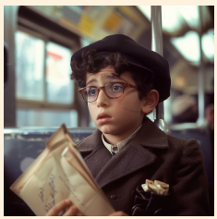

Danny was a nine-year-old boy who lived with his family in London. Danny loved visiting his zeidy and bubby who lived in Manchester and he also loved the two-hour train ride from London to Manchester. Once they boarded the train Danny would cozily sandwich himself between his parents and dreamily watch the city fade into the countryside. Before he knew it, they would arrive in Manchester where his grandparents would always be waiting to fetch them and drive them to their welcoming home.

It Was Such an Easy Commute
As Danny grew, an idea began to formulate in his mind. Wouldn’t it be wonderful if he were to visit his grandparents for a weekend? He would love their undivided attention. And it was such an easy commute as he had ridden the train so many times that he could even travel alone.
Eventually, he built up the courage to run his idea by his parents. Initially, they were adamant that he was way too young to travel on his own, but Danny’s persistence paid off and finally, his parents promised him that for his eleventh birthday weekend, he could visit his grandparents all by himself. Danny counted down the months until he would turn eleven and finally get his wish fulfilled.
At last, the week of Danny’s birthday approached and he anxiously looked forward to the weekend so that he could take his long-awaited trip. On the day of his solo journey, Danny rose early and packed a small case to take along. Truth be told, he did have butterflies in the pit of his stomach both from excitement and from the anxiety of traveling alone.

Growing More and More
Nervous by the Minute
When they arrived at the train station, Danny’s father went to buy him a ticket and even accompanied Danny onto the train. Danny swung his small case onto the shelf above his seat. On the outside he appeared calm and confident but on the inside, he was growing more and more nervous by the minute.
His father, perhaps sensing some of Danny’s apprehension, asked him if he was sure that he was okay traveling all by himself. Danny assured his father that he was okay. After all, it was a short two-hour trip, and anyway, his grandparents would be waiting on the platform as soon as the train arrived in Manchester.

A Folded Piece of Paper
“Well then, goodbye Danny, safe travels,” his father said. But as he said goodbye, Danny’s father pressed a folded piece of paper into Danny’s sweaty palm. “Danny, if for some odd reason you begin to panic or if something happens, just open this note and you will be okay.”
“No worries, Dad, I am just fine,” and with that Danny quickly stuffed the folded note into his coat pocket. Moments later the train pulled out of the station as Danny tried to calm his pounding heart and settle down. But, try as he might, his apprehension just continued to grow. It only got worse when a shady-looking character entered his train car and sat down directly across from Danny. All kinds of frightening thoughts entered his mind and his imagination shifted into overdrive.

Regretted Ever Coming Up with this Crazy Idea
At the next stop, a group of rowdy thugs entered his car and sat near him. Danny began to panic. This was not how he had imagined the train ride and he regretted ever coming up with this crazy idea. The world around him began to spin as the panic intensified and Danny was losing it when he suddenly remembered the paper in his pocket. Frantically, he stuck his hand into his pocket and unfolded the piece of paper.
As he began to read the note, a smile broke out on his face and a sudden calm set in. The note read. “Danny dear, if you are reading this note while still on the train, stay calm and walk to the back of the train. You will find me in the last car waiting for you!”
Danny grabbed his case and quickly walked through the train to the last car. Sure enough, his father was sitting there. Relieved, Danny ran into his father’s arms. He knew that with his father onboard he would surely be okay.
On life’s journey, complications and challenges sometimes arise and suddenly we begin to panic as we feel like we have to go at it all alone. This is so far from the truth, as a Yid always figuratively carries a note in his pocket that says, “Imo anochi b’tzarah — I am with you in your time of need. Just grab your pekel and find Me. I am there for you on your journey!”

Reprinted from the Parshas Korach 5784 edition of At the ArtScroll Shabbos Table. Excerpted from the ArtScroll book – “Flashes of Greatness.”

Who Should Pray for Rachamim (Mercy)?
By J. Gewirtz

A man once came to R’ Yechiel Meir of Gustinin, known as the “Guter Yid,” mentioning a loved one who was sick and needed Rachamim (mercy). The Guter Yid told him to say Tehilim (Psalms). The man replied that he had come to the Rebbe so that the Rebbe should ask Shomayim (Heaven) for Rachamim.
R’ Yechiel Meir said: “Chazal tell us that if one has a sick person in his house, he should go to a chacham (Torah scholar) and he shall pray for him. Chazal did not say ‘to pray for him,’ which would imply that the Chochom should beseech Shomayim for mercy, but rather ‘and you shall pray for him,’ which refers to the one who came to the Chochom.
The Chochom’s role is to guide the petitioner, but the ‘work’ must be done by you.” themselves! (Still, it was R’ Yechiel Meir’s custom that whatever he “assigned” to others, he did himself as well, and he would always daven (pray) for Rachamim for the benefit of those who asked him)

Reprinted from the Parshas Korach 5784 email of Migdal Ohr.

Anti-Semitism at the Zoo
By Aharon Spetner

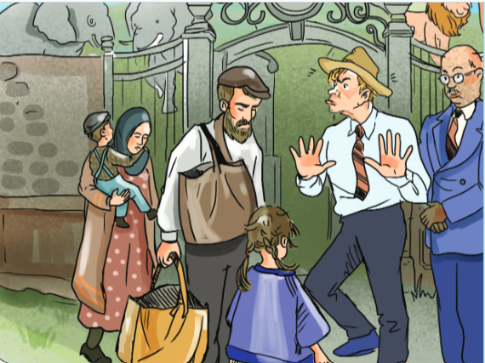
Illustrated by Miri Weinreb

Berlin, May 1, 1933

Israel Hans Wertful looked up hopefully at the sound of the door to his shop opening.
“What’s wrong?” asked his wife, as she entered with their two children. “Aren’t you happy to see me?”
“No, I am, Sara Gretel,” answered Israel Hans. “It’s just that I was hoping that maybe it was a customer.”
“Has anyone come in today?” Sara Gretel asked.

“I May Have to Give Up the Store”
“Just someone asking for tzedakah. I didn’t have a single Reichspfennig to give him.” Israel Hans looked around his shop sadly. “If this Nazi boycott of Jewish businesses continues, I may have to give up the store.”
“I’m so sorry to hear that,” said Sara Gretel gently. “I’ll tell you what. Why don’t you come with us to the zoo? Admission is free today and they are having special animal shows in honor of Erster Mai (the “May Day” celebration).”
Israel Hans took another sad look around his empty store and then at the ragged faces of his children, Aaron Arnold and Hannah Hilda.
“Okay,” he said. “It doesn’t look like any customers are coming anyway.”
Israel Hans locked up the shop and headed down the street with his wife and children. Hannah Hilda skipped along happily as Sara Gretel carried young Aaron Arnold in her arms.

Asking the Visitors for Identification
A few minutes later, they arrived at the entrance to the zoo. A young blonde-haired man was standing outside, asking visitors for identification.
“Israel Hans? Sara Gretel?” he said, looking at the ID cards. “I’m sorry, I cannot allow you inside.”
“Excuse me?” asked Israel Hans. “You’re not letting us in because of our names?”
Another man approached. “Is there a problem here?” he asked.
“Yes, Herr director. Israel Hans and Sara Gretel don’t understand why we won’t allow them into the zoo.”
The director grinned broadly. “Ah, I see. Well, that is very easy to explain. You see, you are clearly Jewish people. And today is a national holiday. We don’t want any filthy foreigners like yourselves soiling a beautiful German celebration.”
“Soil?” asked Sara Gretel. “We are very clean people. We just want to see the animals.”

Threatened to Call the Gestapo
The director’s smile disappeared. “ENOUGH!” He shouted. “Get your dirty Jewish faces out of my sight before I call the Gestapo!”
“Papa, what’s the Gestapo?” asked Hannah Hilda, as the Wertful family hurried down the street away from the zoo entrance.
“It’s the new Nazi secret police force that was created last week,” answered Israel Hans. “We’d best hurry home.”
“I don’t understand,” said Sara Gretel as they approached their small apartment. “We have always been so friendly to our German neighbors. Why are they suddenly being so mean to us?”
Entering their home, Israel Hans stopped and looked at the portrait of his father, Reb Herschel Wertful, hanging in the living room.
“Is everything okay, Papa?” Hannah Hilda asked in a worried voice, as a tear rolled down Israel Hans’s cheek.
“Opa was right,” Israel Hans said, pointing at his father’s picture.
“What do you mean?” asked Sara Gretel.
“Every year, on Shabbos Parshas Chukas, my father would talk about how, on the way to Eretz Yisroel, the Bnei Yisroel asked Edom if they could pass through their land. But Edom refused and instead sent their entire army to greet the Yidden, who then had no choice but to turn around and take a different route.

Preventing Jews from Becoming
Too Friendly with the Goyim
“My father would always say that Hashem did a big favor for Klal Yisroel at that moment. By Edom being ‘mean’ and not letting us through their land, we were prevented from chas veshalom becoming too friendly with the goyim and straying from the Torah.
“My father would warn us to never get too close to our goyishe neighbors, not to try to be like them. But I was young and didn’t listen. I started going by ‘Hans’ so the Germans would want to do business with me. We would celebrate the national holidays with our neighbors so they would want to be friendly with us.
“But now, look what is happening. Hitler decreed that Germans are not allowed to shop at Jewish stores. They force us to use our Jewish names. And now they won’t let us into the zoo on their holiday.”
“I know, it is so sad,” said Sara Gretel.

Hahem is Giving Us a Message
“No!” said Israel Hans. “Hashem is giving us a message and we must listen before it is too late! Hashem is telling us to stop trying to be like the goyim! From now on I want you to call me Yisroel. No more Hans! We must tell everyone we know that we need to return to the purity of Yiddishkeit. If the Jews of Germany can learn the lesson and stay separate from the ways of the goyim, perhaps we can return to the peace we once enjoyed and avoid any further gezeiros.”

Have a Wonderful Shabbos.

Reprinted from the Parshas Chukas 5784 email of Toras Avigdor Junior, Adapted from the teachings of Rav Avigdor Miller zt"l

